/\*\*\*\*\*\*\*\*\*\*\*\*\*\*\*\*\*\*\*\*\*\*\*\*\*\*\*\*\*\*\*\*\*\*\*\*\*\*\*\*\*\*\*

\* Programming excercise 73001 \*

\* Maxwell Stephens \*

\* 12:30 TTh \*

\* 73001, 2/21/17 \*

\*\*\*\*\*\*\*\*\*\*\*\*\*\*\*\*\*\*\*\*\*\*\*\*\*\*\*\*\*\*\*\*\*\*\*\*\*\*\*\*\*\*\*/

/\*

A program that outputs the prime numbers from 3 to 100

\*/

#include <iostream>

using namespace std;

int main()

{

//for loop with nested for loop

//incrementing i from 2 to 100 to get the correct range

for (int i = 2; i < 100; i++)

//nested for loop to test whether or not i is prime

for (int j = 2; j < i; j++)

{

//test to rule out numbers if they equal 0 after being % by j

if (i % j == 0)

break;

//test to see if i is prime by testing if it is equal to 1 plus the non incremented j value in this first case, 2

else if (i == j + 1)

//print the value for i that is prime

cout << i << " \n";

}

system("pause");

return 0;

}

/\*

SAMPLE OUTPUT:

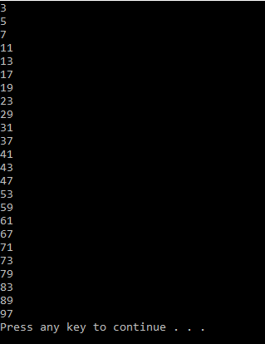

Self-Evaluation:

4: Works perfectly, code properly documented

I believe I earned 4 points.

\*